

Extended Response Task 2 2024

Chromatography and Polarity - Validation

Total Marks: /50
Weighting 5%

Name: __________________________________________________________________________________________

Multiple Choice: (5 marks)

- Retention time can be used to identify a compound in a mixture using gas chromatography.
Which one of the following will not affect the retention time of a compound in a gas
chromatography column?
a) concentration of the compound
b) nature of the stationary phase
c) rate of flow of the carrier gas
d) temperature of the column

2. The paper chromatograph of four dyes, G, P, R and Y, is shown below.
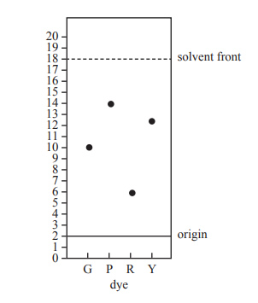
The Rf value of the dye most strongly adsorbed onto the stationary phase is
a) 0.25
b) 0.33
c) 0.75
d) 0.78
3. A thin layer chromatography (TLC) plate was set up with hexane as the mobile phase and silica gel as the stationary phase. The chromatogram below was obtained.
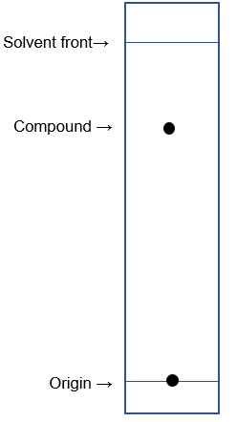
Which one of these best describes the polarity of the components?

Compound Stationary phase Mobile phase
a) polar polar polar
b) non-polar polar non-polar
c) non-polar non-polar non-polar
d) non-polar non-polar polar

4. One use of thin layer chromatography (TLC) is in the analysis of urine samples taken from professional athletes. TLC can be used to detect whether any illegal substances are present in the urine. Consider the two TLC plates below which have been run under identical conditions. On the left is a control plate, showing the markers for the illegal substances cocaine, methamphetamine and heroin. On the right is a test urine sample.

Control plate Test urine sample

solvent front
4.8 cm
2.5 cm
solvent front
cocaine
methamphetamine
heroin
6.7 cm
5.1 cm
1.8 cm
3.5 cm

Has the urine sample tested positive for any of the illegal substances?

- Yes, cocaine.
- Yes, methamphetamine.
- Yes, heroin.
- No, none.

5. Thin layer chromatography (TLC) was performed on five (5) different essential oils; bergamot, eucalyptus, lavandula, orange and pine. The TLC plate is shown below, along with the corresponding R_{f} value for each resolved component.

bergamot eucalyptus lavandula orange pine
R_{f} = 0.883
R_{f} = 0.5
R_{f} = 0.5
R_{f} = 0.233
R_{f} = 0.367
R_{f} = 0.267
R_{f} = 0.267
R_{f} = 0.667
R_{f} = 0.567
R_{f} = 0.417
R_{f} = 0.667

A small amount of an unknown essential oil, labelled as ‘Sample X’, was then analysed by TLC using identical running conditions. This plate is shown below. Use the data provided to determine which two essential oils have been mixed to produce ‘Sample X’.

solvent front = 5.5 cm
4.86 cm
3.12 cm
2.75 cm
1.28 cm

- Bergamot and pine.
- Eucalyptus and lavandula.
- Orange and eucalyptus.
- Lavandula and pine.

Short Answer (45 marks)

6. The catalytic converter in a car takes in the undesirable gases produced by the combustion of petrol, such as carbon monoxide and various nitrogen oxides, and converts them into less harmful gases such as carbon dioxide, nitrogen gas and water. The less harmful gases are released into the atmosphere as we drive.

NO_{x} catalytic N₂
hydrocarbons converter H₂O
CO CO₂

Metals such as platinum, palladium and rhodium are used as the catalyst in a catalytic
converter.

a) The table below shows the major gaseous products to exit a catalytic converter.
Complete this table by drawing the electron dot diagram for each of the three gases,
representing all valence shell electron pairs either as : or –. In addition, state the shape of
the molecule, and indicate whether or not the molecule is a polar molecule. (9 marks)

 | Electron Dot Diagram | Molecular Shape | Polar molecule (‘yes’ or ‘no’)
N₂
CO₂
H₂O

A sample of exhaust fumes from a car was analysed by gas chromatography (GC) to determine the composition of the fumes and assess the effectiveness of the catalytic converter.

b) Briefly describe the principles of gas chromatography and state one reason why GC may have been chosen over other forms of chromatography to perform the analysis in this situation. (4 marks)

__________________________________________________________________________

__________________________________________________________________________

__________________________________________________________________________

__________________________________________________________________________

__________________________________________________________________________

__________________________________________________________________________

__________________________________________________________________________

__________________________________________________________________________

__________________________________________________________________________

__________________________________________________________________________

The data below shows GC standards for four of the relevant gases, as well as the chromatogram obtained from analysis of the car exhaust fumes.

The two chromatograms below, for methane and carbon monoxide, were obtained from the analysis of car exhaust fumes that do not pass through a catalytic converter.

The two chromatograms below, for nitrogen and carbon dioxide, were obtained from the analysis of exhaust fumes released from an efficiently functioning catalytic converter.

The chromatogram for the sample of exhaust fumes being analysed is shown below.

c) Elaborate on the information provided by this data, in terms of the composition of the car exhaust fumes and the effectiveness of the catalytic converter. (3 marks)

__________________________________________________________________________

__________________________________________________________________________

__________________________________________________________________________

__________________________________________________________________________

__________________________________________________________________________

__________________________________________________________________________

__________________________________________________________________________

__________________________________________________________________________

7. High performance liquid chromatography (HPLC) has many useful applications, with one of the most common being in the monitoring and analysis of additives used in food and beverages. A common additive found in many low calorie food and drink products is the artificial sweetener known as ‘aspartame’. The safety of aspartame has been studied extensively over the years, with many people reporting side effects such as nausea, dizziness and abdominal pain. Whilst it is still classified as a ‘safe substance’ by various food and health organisations, many people choose to avoid aspartame consumption.

A chemist decided to run some tests to compare the aspartame levels found in four different types of soft drink, and she used HPLC to perform the analysis.

a) Discuss the chemical principles behind the process of HPLC by answering the following questions.

- What physical properties must a sample have to make it appropriate for HPLC analysis to be used? (2 marks)

__________________________________________________________________________

__________________________________________________________________________

__________________________________________________________________________

__________________________________________________________________________

__________________________________________________________________________

- Describe how HPLC is able to separate the components of a sample, in particular focussing on the role of polarity in the process. (4 marks)

__________________________________________________________________________

__________________________________________________________________________

__________________________________________________________________________

__________________________________________________________________________

__________________________________________________________________________

__________________________________________________________________________

__________________________________________________________________________

__________________________________________________________________________

__________________________________________________________________________

__________________________________________________________________________

__________________________________________________________________________

The chemist used previous HPLC data to produce the ‘control’ chromatogram shown below, which displays the retention times for several common soft drink additives, including aspartame.

She then ran HPLC analysis on samples of four (4) different soft drinks; Pepsi, Diet Pepsi, Pepsi Max and Fanta Orange. The individual chromatograms for each soft drink are shown below. You may assume they were carried out under the same HPLC conditions as the ‘control’ above.

b) Which of the soft drinks contained aspartame? Name the drink with the highest aspartame concentration. (2 marks)

________________________________________________________________________

________________________________________________________________________

The chemist wanted to quantify her data, so she ran HPLC on a series of aspartame standards to produce a calibration curve. The results obtained from this are summarised in the table below.

Aspartame concentration  (g L⁻¹) | Absorbance units
0.1 | 70
0.2 | 135
0.3 | 200
0.6 | 410

c) Plot the calibration curve for aspartame on the grid below. (5 marks)

Calibration Curve for Aspartame

d) List two (2) controlled variables the chemist would have had to consider when performing HPLC on the various aspartame standards. (2 marks)

__________________________________________________________________________

__________________________________________________________________________

__________________________________________________________________________

8. Below is the detector read-out from a high performance gas chromatography apparatus analysing the organic residues inside a chemical reaction tank using a polar stationary phase in the column. The mobile phase used was helium which had a column retention time of
0.6 minutes, as seen from the graph.

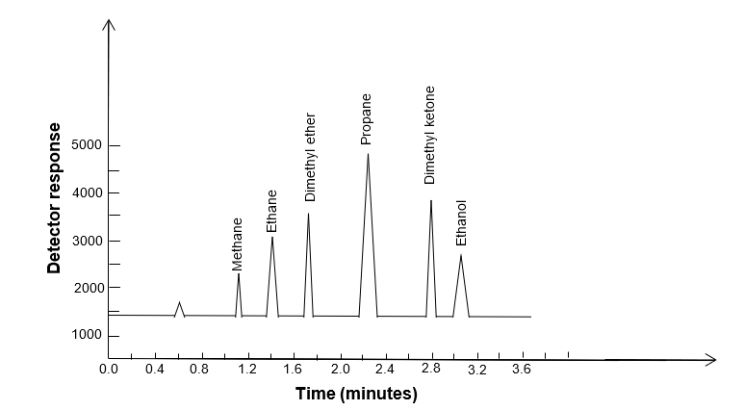

a) Which compound in the tank was present in the greatest concentration? (1 mark)

__________________________________________________________________________

b) Which compound had a Retention Factor of 0.34? Show calculations. (3 marks)

c) Which compound being tested is the least polar? Explain. (3 marks)

__________________________________________________________________________

__________________________________________________________________________

__________________________________________________________________________

__________________________________________________________________________

__________________________________________________________________________

d) By considering the bonding types, explain why the Retention Time for ethanol would
be the greatest. (2 marks)

__________________________________________________________________________

__________________________________________________________________________

__________________________________________________________________________

__________________________________________________________________________

9. Analysis of various hair products such as dyes, sprays and serums can be of great benefit to forensic investigators. Since hair samples are often found at crime scenes, identification of the hair products which are coating the hair can provide valuable information to investigators.
One common and effective method used for the analysis of hair products is thin layer chromatography (TLC). The TLC plate below shows the analysis of six (6) different popular brands of hair spray.

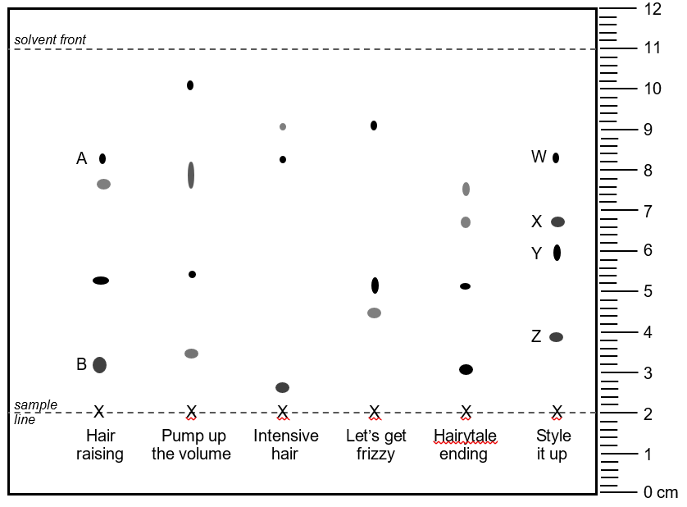
A hair sample from a crime scene was analysed by TLC and found to be coated in the hairspray ‘Style it up’.

a) Calculate the retention factor (R_{f}) values for each of the components (labelled W, X, Y and Z on the TLC plate) found in the hairspray ‘Style it up’. (4 marks)

R_{f}
W
X
Y
Z

Hair samples were then taken from three (3) suspects who had been arrested. The coatings on their hair samples were analysed by TLC. You may assume this analysis was performed under conditions identical to the original plate.

The results of the suspects’ TLC analyses are shown below.

Miss White Mrs Peacock Miss Scarlet
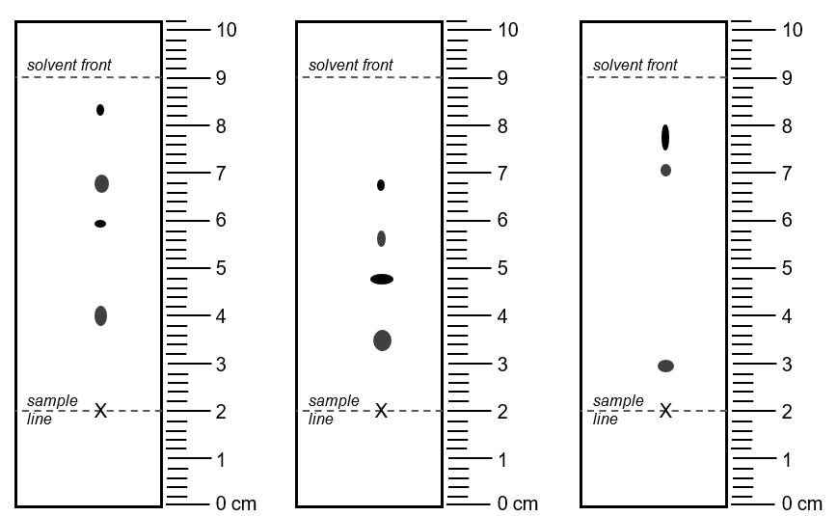

Based on the data provided by these TLC analyses;

b) Which suspect is most likely to have been at the scene of the crime? (1 mark)

________________________________________________________________________

End of Validation

